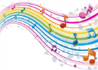

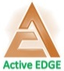

Entry / Exit points:

Entry point: Percy Jackson & the Olympians: The Lightning Thief
Exit point: This half term the children will be hosting an Olympic themed event, which parents are invited to attend.

After half term, children will be visiting a Roman Villa and ending with presentations about Roman and Greeks.
Music

In this half term, our focus will be to improvise and compose music for a range of purposes.
The children will be developing an appreciation for a wide range of music. After which, they will have the chance to compose and perform their own piece.
We will focusing on the genres of Rap and Pop Ballards

Active

In the first half term, children will be developing their gymnastic skills. This will include creating sequences and using apparatus. As well as this they will be developing their skills in net and wall games.
After half term, children will be creating a dance based on Roman dance as well as developing their skills in rounders.

Forest School will be on a Wednesday morning – Children to come wearing kits
Science

In this half term, our focus is ‘Animals including humans’
Our focus will be looking at changes from foetus to old age and physical changes within each stage.

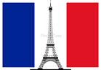
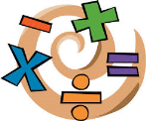

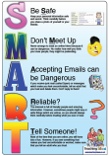
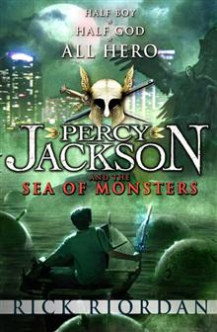


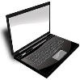

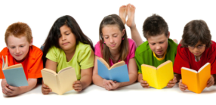

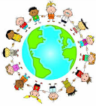
n
French

Pupils will learn the French for clothing, whether it is feminine or masculine, plural or possessive. This will be taught by Mde Haines.
Maths

Our main focus for maths in the first half term will be fractions, decimals and percentages.

Children will look at comparing and ordering fractions, identifying and name equivalent fractions and read and write decimal numbers.

We’ll also be taking problem solving further by practicing the skills of visualising and constructing calculations in the real world.

Times tables and mental maths will also continue to play a vital part in the maths learning.
Art/DT

Pupils will use a variety of skills as they:

- Taste and evaluate Greek foods
- Design and create their own Greek foods
- Research and evaluate Roman mosaics
- Design and create their own mosaic

Eagles & Kestrels
2019 - 2020


History/Geography

The topic for the term is ‘The Great, The Bold, and The Brave’.
In Geography, the children will be learning about Greece, including where it is and its customs. In History, they will be learning about the Olympic games and life in Ancient Sparta.

Computing

Pupils will be learning about networks: how they are used and how they share data, whilst all the time ensuring, they behave safely and SMART online. Children will also be using the software ‘Prezzi’ to create presentations for parents.

English

We will be basing our reading and writing on the book ‘Percy Jackson and the Sea of Monsters’.

We will all be developing our spelling, grammar and punctuations skills alongside increasing our vocabulary and practicing the neatest handwriting.

Fiction Writing: We will be reading the book mentioned above and planning their own Greek story based in Greece.

RE / PSHCE

In RE pupils will be learning about Christianity: who Jesus was and creating a video in the form of a news report presenting evidence claiming that the Messiah has arrived. After half term children will be learning about Judaism including the Jewish commandments.

